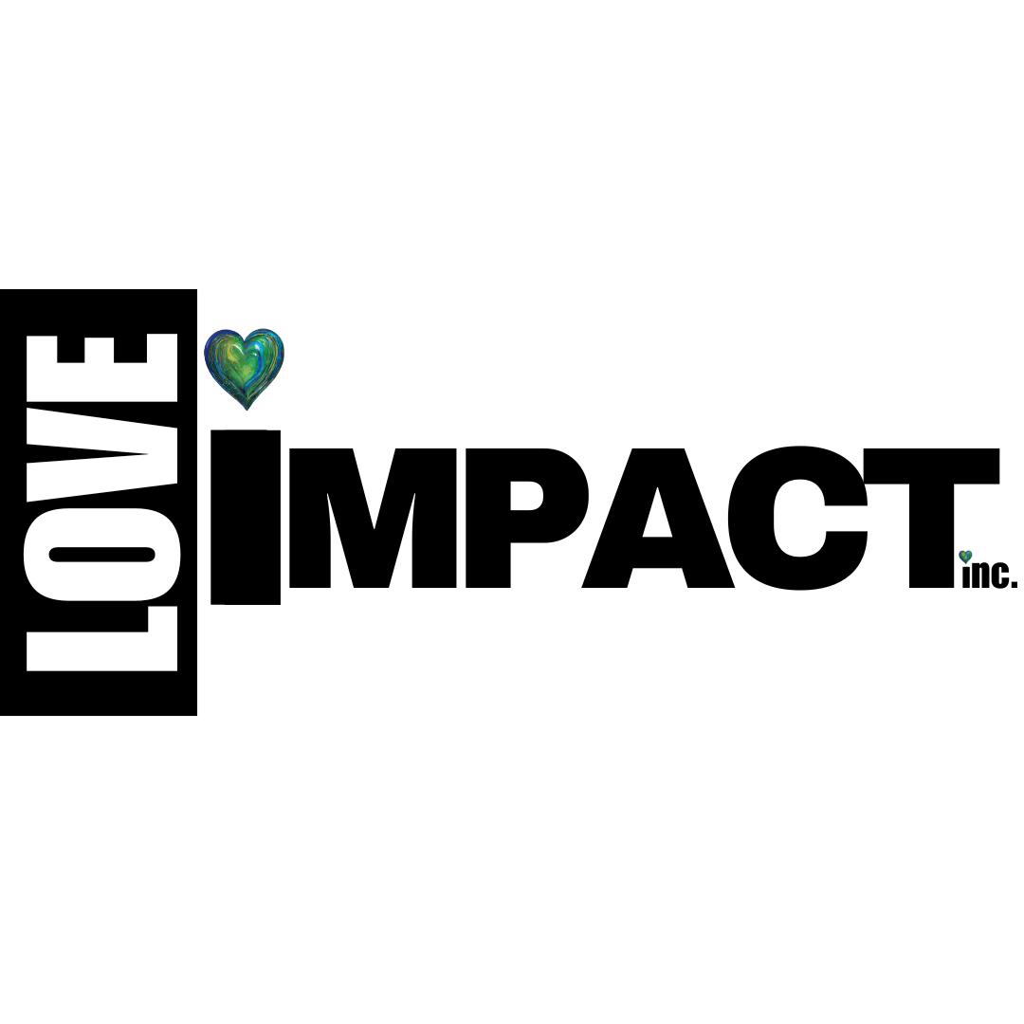

**Organizational Profile**

|  |
| --- |
| Table of Contents |

Organization Information 1

Mission Statement 2

History of Organization 2

Constituent Demographics 2

Program One Description: 3

Program Two Description: 4

Program Three Description: 5

|  |
| --- |
| Organization Information |

|  |  |
| --- | --- |
| Name of Organization | Love Impact, Inc. |
| Primary Contact | Daysha J.P. Underwood |
| Primary Contact Email | daysha@loveimpactinc.org |
| Website URL | www.loveimpactinc.org |
| 5 Keyword Search Descriptors  *Tutoring, afterschool, STEM, college access, career exploration* | Health & Wellness, Youth Development, Rollerskating, Dance Fitness, Intergenerational , Culturally Relevant |
| Physical Address  *Where your programs are administered. No PO Box*  *\*Unless its UPS* | 44620 Valley Central Way #1031 Lancaster, Ca. 93536 |
| Mailing Address  *Where you receive mail/bills* | 44620 Valley Central Way #1031 Lancaster, Ca. 93536 |
| EIN | 93 1815520 |

|  |
| --- |
| Mission Statement |

*What’s the ‘missing” in your service area? How will you fill the gap? Who benefits?*

*Current vision & mission:*

*Vision:* ***We envision a world transformed by the impact of love and wellness, where our communities live longer, happier, healthier lives.***

*Mission:* ***Passing on the gift of culturally relevant, holistic wellness and self-love from generation to generation***

*Possible Updates:*

*Inspiring youth and adults to feel loved, valued, connected, and well.*

*Impacting lives with love through culturally affirming wellness.*

*To provide culturally affirming wellness opportunities to historically marginalized communities.*

*Helping historically marginalized communities feel the impact of love through culturally affirming wellness.*

*Empowering historically marginalized communities to feel loved, valued, and well through culturally affirming wellness.*

|  |
| --- |
| History of Organization |

|  |  |
| --- | --- |
| Year of Inception | 2020 |
| Year of Incorporation | 2023 |
| Origin Story  *How did the organization form?* | Love Impact, Inc. was founded in 2023, in an effort to provide more culturally affirming wellness opportunities in Los Angeles County. |
| Why was the organization founded?  *Was there an incident, a personal experience?* | Founder, Daysha J.P. Underwood who is a certified dance fitness instructor and roller skater, found fitness and wellness spaces were lacking in representation of historically marginalized communities. She also noticed a pattern of negativity and poor self-image in the pursuit of wellness. She wanted to change this. At Love Impact, Inc. we believe that it is a human right to feel loved, valued, connected, and well.  I was born and raised in the Antelope Valley. I love my hometown, yet to the outsider looking in, there is much to be desired. Sometimes the Antelope Valley gets a *bad rep*. They say, “Oh the AV; there’s just nothing to do out there.” They say, “Oh the AV; is boring” or worse, “Unsafe.”  We are not a throw away community.  What I know from experience is that despite our growth areas, the Antelope Valley is a community full of creativity and joy for life. We have a vibrant senior community and many brilliant young minds with the desire to connect with others. LoveFit started based on my background in fitness. I realized people entered fitness spaces with a heaviness and with a perspective that somehow they were lacking something. They were coming to class to "fix" what they did not love about their bodies. I wanted to create a space where we value wellness in a way that still supports our own emotional wellbeing. We can exercise in a way that pursues holistic wellness and affirms and celebrates who we are. This is how LoveFit began.  I am also an avid roller skater. I’d been driving 2 hours outside of my community to skate. Eventually, I began arranging local skate meet ups at the park. I made some local connections and received the opportunity to advocate for space in our community. We did our first indoor roller skate event in celebration of Black History Month in Lancaster. |
| What has been the organization’s largest program challenge?  *Not funding. It should be something tangible* | The most difficult challenge has been securing space to meet the specific needs of our programming and building trust with community partners and agencies who can provide access to those needed spaces. With roller skating and dance fitness provided as some of our most popular wellness programs, there are specific needs that will determine if a space is suitable/functional for our programming needs. |
| How has the organization overcome that challenge?  *The answer should demonstrate your ability resolve a problem.* | We have built community trust and visibility. After multiple outdoor events, our first indoor community skate event happened at a small dance studio. We eventually outgrew this location. I was given the opportunity to advocate for culturally relevant spaces for the African American community at the City of Lancaster Equity Commission meeting. This was a success! After a follow up meeting with the Director of PARCS, our first City of Lancaster supported event was the next month in February as a celebration of Black History month. We continued this partnership for a year providing local skate programming on a biweekly basis in a community space. We also further solved this issue by building multiple pop-up roller rinks for community events such as a Celebration of Juneteenth, with our largest rink being 2500 square feet.  We proved that we can not only advocate for space for our community, but build it too. |
| What is the organization’s greatest accomplishment since its inception?  *Since 2020, the organization has partnered with 25 LAUSD school districts to graduate 100% of its participants (30,000 African American males), provided over $9 million in college scholarships, placed over 3,750 youth in internships and assisted 5,571 with landing entry level professional and paraprofessional jobs.* | Since 2020, Love Impact, Inc. has provided culturally relevant opportunities for wellness, incorporating music and movement opportunities during both programming and events for over 5,000 people.  LoveFit participants express feelings of gratitude and joy in their weekly program participation.  Notes:  Peace Love & Skate  Biweekly events - 20+X 26 =  Pop-Up Rinks - 600+ x 6 = 1300  BLVD Dance Pop-Up = 1000  LoveFit |

|  |
| --- |
| Constituent Demographics |

|  |  |
| --- | --- |
| Target Population  *Gender, age, socioeconomic status: infants 0- 4, youth 5-13, Females ages 14-18. Young adults 19-24 from underserved, urban communities. Adults with disabilities ages 25- 55 in the San Fernando Valley. Seniors 55+, afflicted with dementia or Alzheimer’s* | Primary focus historically excluded communities most specifically Black/African Americans  Seniors, Adults, & Youth  *Our programs are intentionally intergenerational to create cross-generation connections. Our elders hold a wealth of cultural knowledge and wisdom. Youth and young adults often bring innovative ideas. The contrasting elements make for a wellness space full of rich cultural exchange. Creating spaces that allow for the continuity of culture and celebration of identity. |
| Number of Clients Served  *Include the timeframe, monthly, quarterly, annually. e.g., 100 youth per month* | Approximately 90 participants monthly - LoveFit |
| Geographical Service Area(s)  *Country. Community, City, State, i.e., The West Athens Community of South L.A.* | Antelope Valley, Los Angeles County |
| Describe the Gap Your Organization Will Fill  *List resources, training, education, opportunities, role models, alternatives, access, etc.* | Culturally relevant wellness  Self-Love Education and Emotional Wellbeing |
| Describe the Innovation in How Your Organization Fills the Gap  *Math tutoring by African American Alumnae Engineers, On-the-job training with industry professionals, Homework assistance via app.* | Peace Love & Skate *Intergenerational* Roller Skate program allowing cross-generation connection from age 3-60+ on a bi-monthly basis with larger culminating events in the form of outdoor community pop-up rinks. The method and flooring used to create the pop-up rinks is completely different from any other pop-up rinks created in Southern California.  LoveFit unlike other dance fitness or fitness programs places the primary program focus on self-love by incorporating elements of affirmation, meditation, and gratitude into this afrocentric dance class. Casual expressions of negative views of self or body image are not permitted in the program. Participants participate in a self-love rewards program that incentivizes their self-love practice.  Crown & Cradle Doula Services provides doula and home care services primarily to Black mothers in the Antelope Valley.  Sweet Day Self-Love - Self-Love Education and Wellness tailored to meet the needs of Black Women  (Events needs to be eventually transitioned to programming)  Art for Autism (not active yet)  All of these programs are culturally affirming. They are open to all, but built in a way that intentionally aligns with comm |

|  |
| --- |
| Program One Description: |

|  |  |
| --- | --- |
| **Program Title**  *Sexy Title i.e.,* *From Boys2Men Rites of Passage* | LoveFit |
| **Services Provided**  *Youth development*  *College Readiness*  *Career Exploration*  *Relationship Counseling*  *Parenting Classes* | Health & Wellness  Youth Development  Intergenerational Connection  Culturally Relevant Wellness  Senior Wellness  Movement & Dance |
| **Measurable Goals**  *What will you do to make the change? i.e., increase, decrease, reduce, eliminate, cure.* | Increase physical and emotional wellness.  This will be measured through pre and post-program surveys.  Decrease Isolation |
| **By How Much (Impact)**  *% - make the goal attainable. Usually 10-25%* | Participation at least 4  By 20% |
| **Program Objectives**  *How will your org accomplish the goal? By hosting three interviewing techniques workshops per week* | Our LoveFit program will host weekly self-love dance fitness classes, encouraging participants to practice self-love and gratitude through dance fitness  Participants will be enrolled in our LoveFit rewards program to incentivize them on their self-love journey. |
| **How often are your programs offered?**  *e.g. 3 times a week, 4 times a month, once a quarter, twice a year* | At least Weekly |
| **How long will your programs run?**  *e.g., 1 hour, 2 hours, 4 hours*  *for 12 weeks, 6 months, 1 year* | 1 year |
| **Program Description**  ***Boys2Men Rites of Passage*** *is a male youth development program for young African American men ages, 12-24 from the Watts, Compton, West Athens communities of South Los Angeles. Youth are partnered with professional African American men, ages 25-65 who model positive characteristics, decision-making, healthy relationships and career choices. Participants attend a two-hour workshop every Saturday for 12 weeks, covering topics from peer pressure to goal setting, college, and career exploration, to healthy relationships. The goal of the Boy2Men Rites of passage program is to reduce the school-to-prison pipeline by 25% from these underserved, overrepresented communities by 2025.* | LoveFit is a self-love dance fitness program, this program is based primarily in the Antelope Valley Area, but travels throughout Los Angeles County to provide self-love dance fitness. Participants attend a weekly 1 hour dance fitness, meditation, and affirmation session. It includes a self-love rewards program and LoveFit application to support participants in their self-love journey. |

|  |
| --- |
| Program Two Description: |
|  |

|  |  |
| --- | --- |
| **Program Title**  *Sexy Title i.e.,* *From Boys2Men Rites of Passage* | Peace Love & Skate |
| **Services Provided**  *Youth development*  *College Readiness*  *Career Exploration*  *Relationship Counseling*  *Parenting Classes* | Youth Development  Health & Wellness  Intergenerational Connection  Culturally Relevant Wellness  Roller Skating |
| **Measurable Goals**  *What will you do to make the change? i.e., increase, decrease, reduce, eliminate, cure.* | Increase physical and emotional wellness.  This will be measured through pre and post-program surveys. |
| **By How Much (Impact)**  *% - make the goal attainable. Usually 10-25%* | 15% |
| **Program Objectives**  *How will your org accomplish the goal? By hosting three interviewing techniques workshops per week* | Host bi-monthly roller skate workshops helping youth build their confidence and connection to culture and community. |
| **How often are your programs offered?**  *e.g. 3 times a week, 4 times a month, once a quarter, twice a year* | 2 times a month |
| **How long will your programs run?**  *e.g., 1 hour, 2 hours, 4 hours*  *for 12 weeks, 6 months, 1 year* | 8 months per year |
| **Program Description**  ***Boys2Men Rites of Passage*** *is a male youth development program for young African American men ages, 12-24 from the Watts, Compton, West Athens communities of South Los Angeles. Youth are partnered with professional African American men, ages 25-65 who model positive characteristics, decision-making, healthy relationships and career choices. Participants attend a two-hour workshop every Saturday for 12 weeks, covering topics from peer pressure to goal setting, college, and career exploration, to healthy relationships. The goal of the Boy2Men Rites of passage program is to reduce the school-to-prison pipeline by 25% from these underserved, overrepresented communities by 2025.* | Peace Love & Skate is a program that honors the cultural significance of roller skating in the Black community, while welcoming all to participate.  Bi-monthly roller skating workshops teach youth new skills and allow them to build confidence and connection with their culture and community. |

|  |
| --- |
| Program Three Description: |

|  |  |
| --- | --- |
| **Program Title**  *Sexy Title i.e.,* *From Boys2Men Rites of Passage* | Crown & Cradle Doula Services |
| **Services Provided**  *Youth development*  *College Readiness*  *Career Exploration*  *Relationship Counseling*  *Parenting Classes* | Maternal Wellness & Support |
| **Measurable Goals**  *What will you do to make the change? i.e., increase, decrease, reduce, eliminate, cure.* | Reduce the rate of African Maternal and Infant Mortality. |
| **By How Much (Impact)**  *% - make the goal attainable. Usually 10-25%* | 15% |
| **Program Objectives**  *How will your org accomplish the goal? By hosting three interviewing techniques workshops per week* | Provide Doula Services to at least 3 Black Mothers in the Antelope Valley. |
| **How often are your programs offered?**  *e.g. 3 times a week, 4 times a month, once a quarter, twice a year* | 3 meetings prenatal  Labor & Delivery  4-6 meetings postpartum |
| **How long will your programs run?**  *e.g., 1 hour, 2 hours, 4 hours*  *for 12 weeks, 6 months, 1 year* | Ongoing throughout the year based on pregnancies. |
| **Program Description**  ***Boys2Men Rites of Passage*** *is a male youth development program for young African American men ages, 12-24 from the Watts, Compton, West Athens communities of South Los Angeles. Youth are partnered with professional African American men, ages 25-65 who model positive characteristics, decision-making, healthy relationships and career choices. Participants attend a two-hour workshop every Saturday for 12 weeks, covering topics from peer pressure to goal setting, college, and career exploration, to healthy relationships. The goal of the Boy2Men Rites of passage program is to reduce the school-to-prison pipeline by 25% from these underserved, overrepresented communities by 2025.* | Crown & Cradle Doula Services offers support to primarily African American mothers in the Antelope Valley. Mothers are partnered with a certified doula who will offer support with planning, wellness, and advocacy over the duration and after the birth of the child. Crown & Cradle honors the each birthers crown, supporting their mental health & wellness. |

***Sample Organizational History***

*Boys2Men was started in the basement of a school counselor, James Johnson’s home in Newark, New Jersey in1989 after witnessing 75% of his male African American freshmen class fall prey to gangs, drugs, teen pregnancy and prison. In 1990, the organization became a 501(c)(3) nonprofit and began administering programs in local elementary and high schools to disrupt the school to prison pipeline ravaging through predominantly under sourced, underserved Black and Brown communities. In 1992, after the L.A. civil unrest, the West Coast Chapter of B2M was incorporated to address the devastating number Black males in Watts, Compton and the West Athens communities of South L.A. entering prison or being killed. Since 2020, the organization has partnered with 25 LAUSD school districts to graduate 100% of its participants (30,000 African American males), provided over $9 million in college scholarships, placed over 3,750 youth in internships and assisted 5,571 with landing entry level professional and paraprofessional jobs.*